CST 229 – Assignment 4 part 1
Wilsonville, Fall 2017

For problems 1 – 4 use the alphabet Σ = { a , b }. Create a context-free grammar and PDA for the following languages.

- The language that consists of all strings containing ‘aaa’.

S → CaaaC
C → a | b| CC | λ

‘babaaabbb’
S
CaaaC
CCaaaC
CCCaaaC
bCCaaaC
baCaaaC
babaaaC
babaaaCC
babaaaCCC
babaaabCC
babaaabbC
babaaabbb

RE =(a|b)*aaa(a|b)*
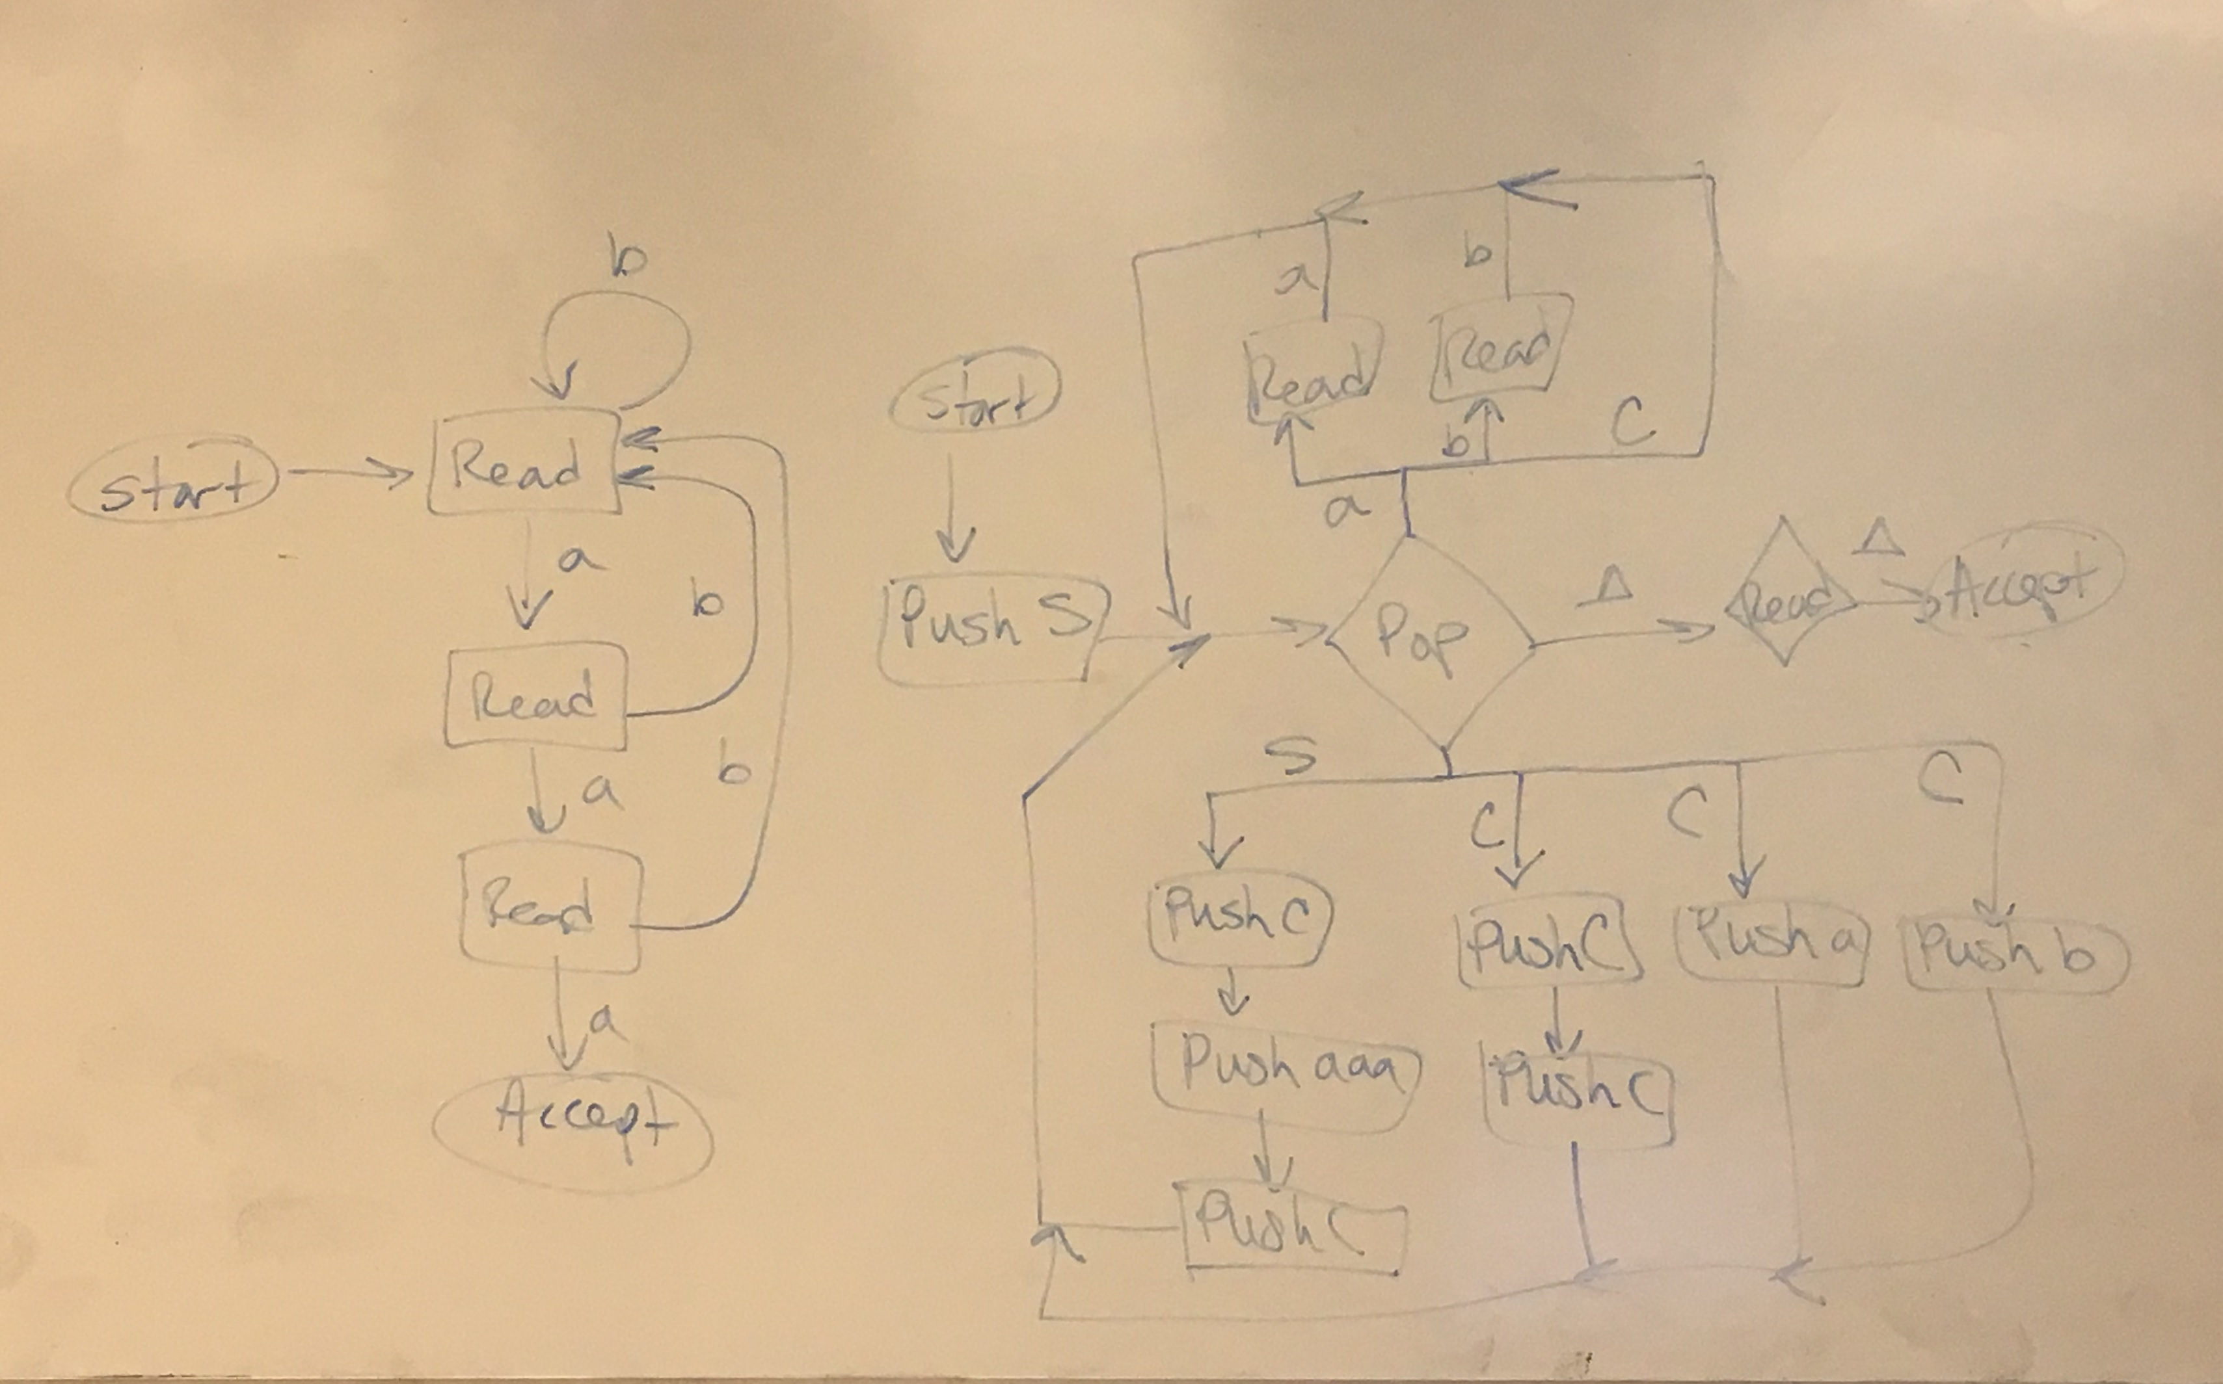

- The language that consists of all strings where the first letter equals the last letter.

S → aCa | bCb
C → a | b| CC | λ

RE = (a(a|b)*a) | (b(a|b)*b)
‘abbbaaaa’
S
aCa
aCCa
abCa
abCCa
abbCa
abbCCa
abbbCa
abbbCCa
abbbaCa
abbbaCCa
abbbaaCa
abbbaaCCa
abbbaaaCa
abbbaaaa

‘abab’
S
aCa
aCCa
abCa
abCCa
<not in language>
PDA:
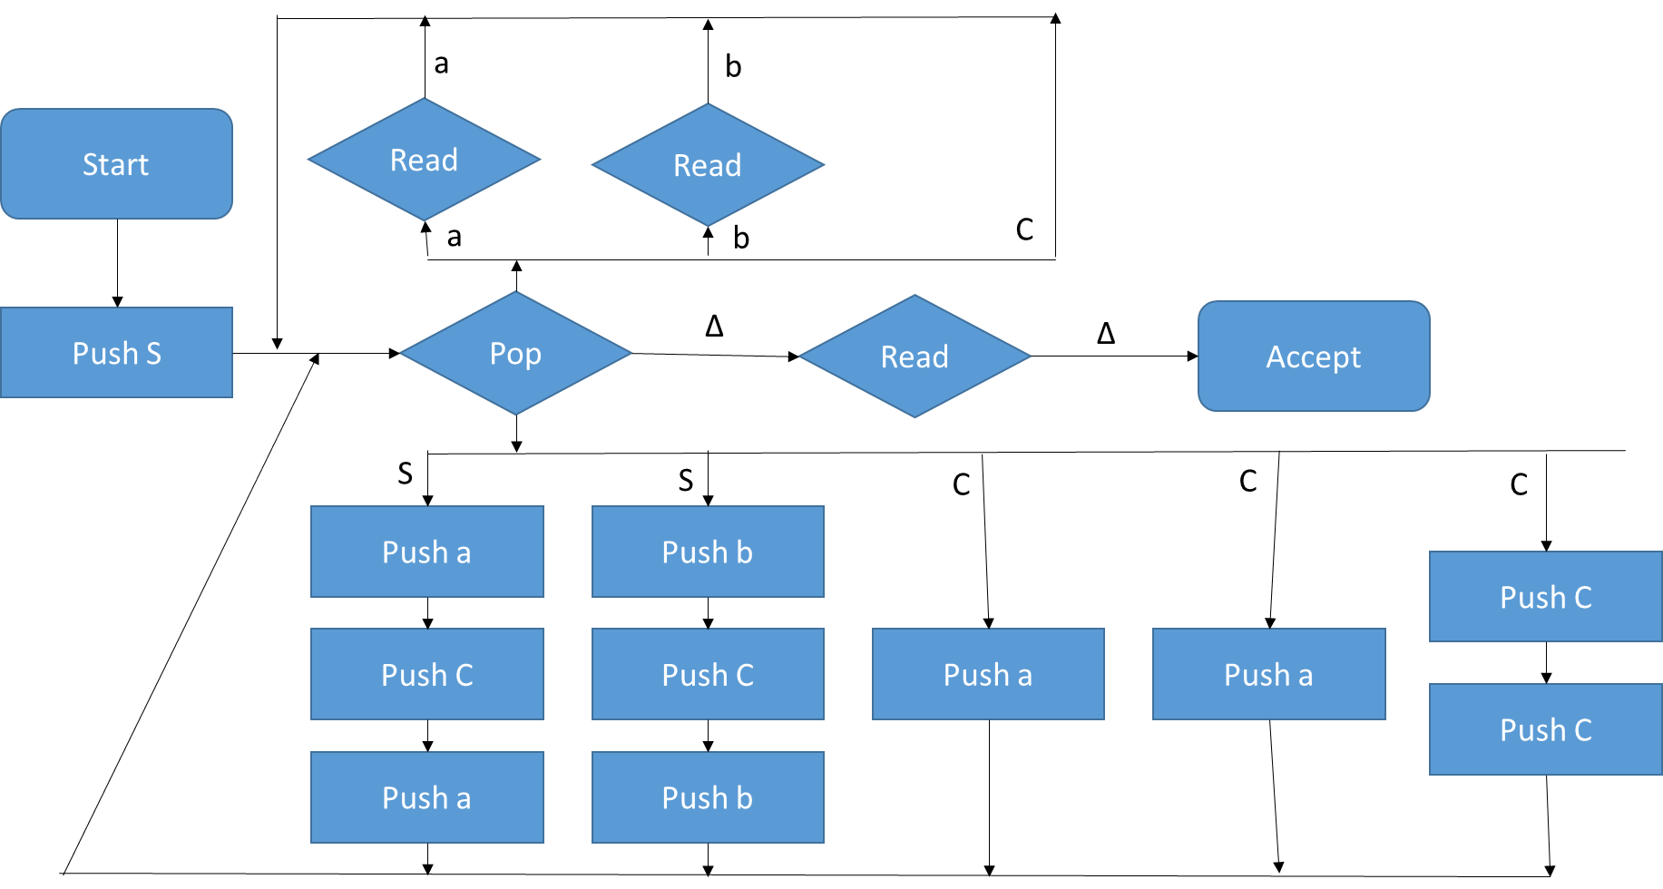

- The language consisting of all strings of odd length.

S→ aC | bC
C→ aaC | bbC | abC | baC | λ

‘ababab’
S
aC
abaC
ababaC
<not in language>

‘bbabbab’
S
bC
bbaC
bbabbC
bbabbabC
bbabbab

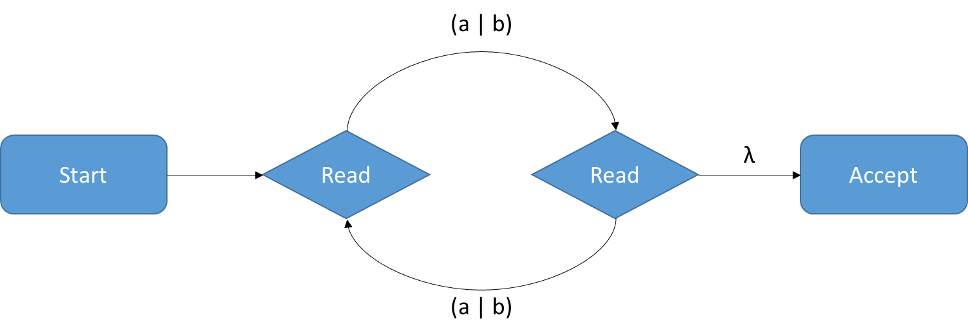

- The language L = {a^{m}b^{n} : m ≠ n}.

S→ C | V
C→ aCb | Cb | b
V→ aVb | Va | a

PDA:
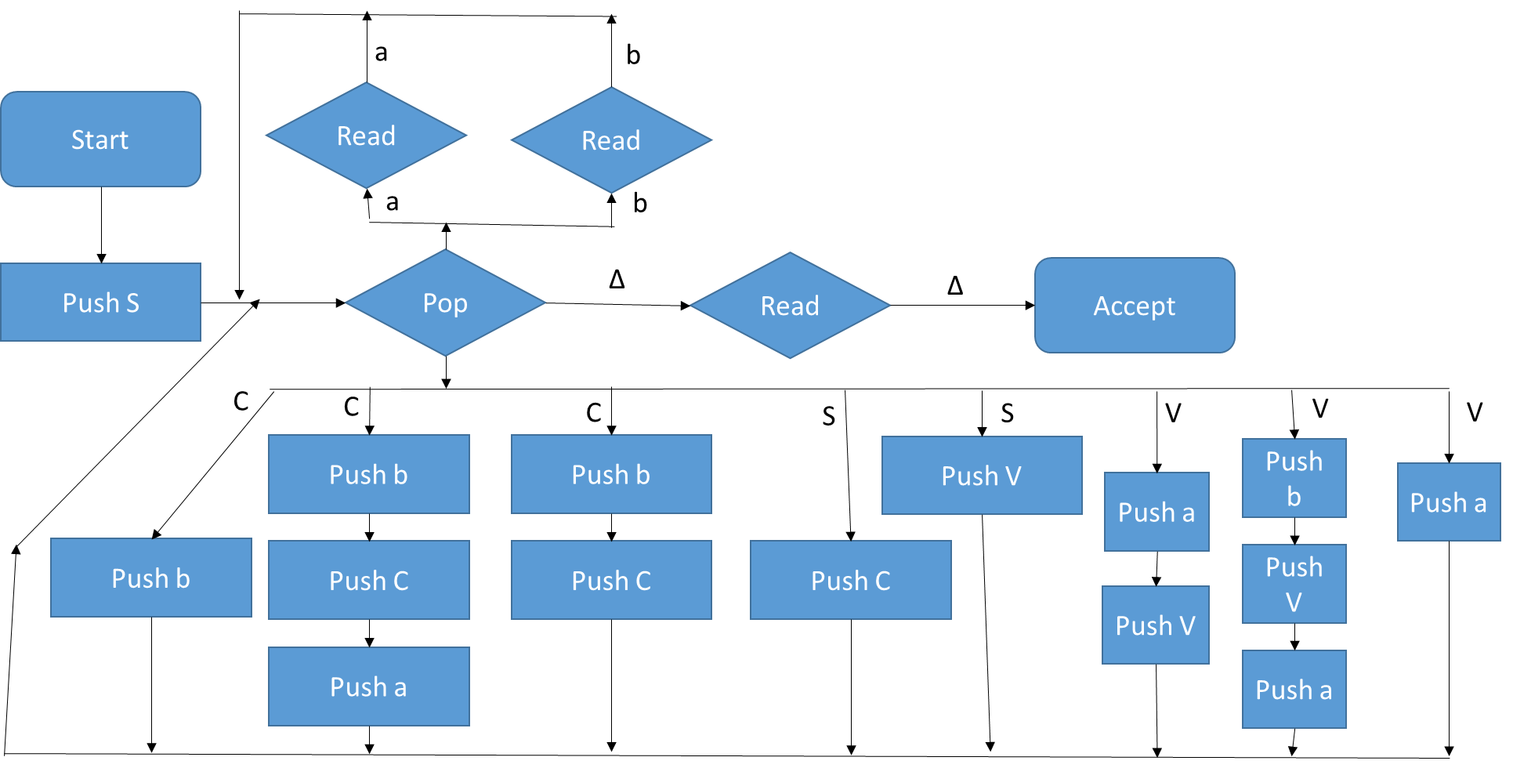
For problems 5 – 7 assume that all Turing machines start on the leftmost symbol of the input string, and the tape is blank except for the string.

- Create a Turing machine that takes an input string of 0’s and 1’s. The machine should convert all 0’s to 1’s, and all 1’s to 0’s. The machine should halt on the start (i.e. left hand side) of the resulting string.

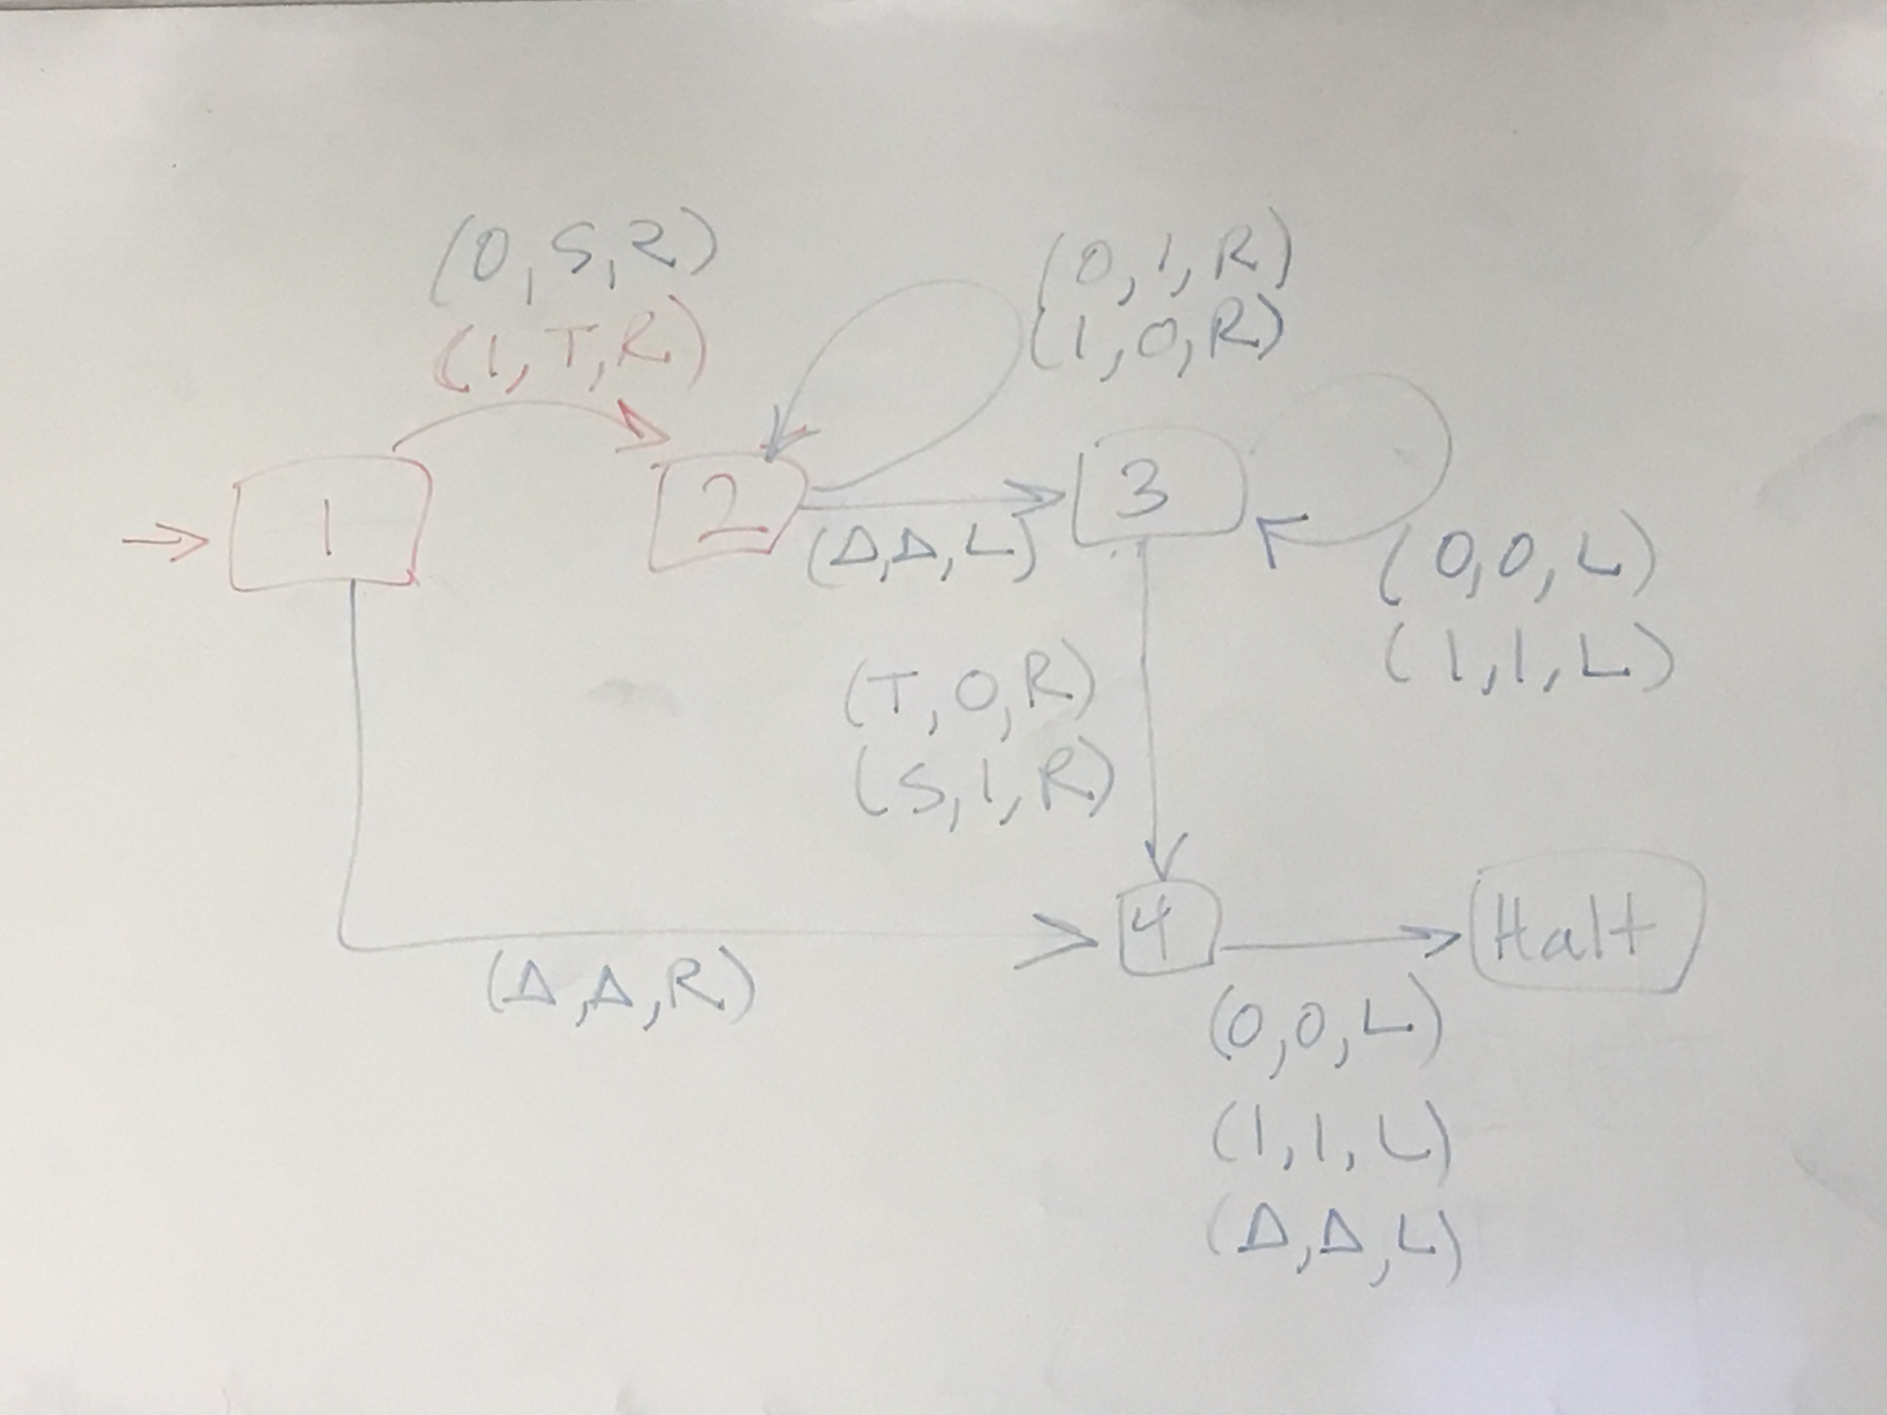

- Create a Turing machine that accepts the strings for the language defined by the RE “a*b*”.

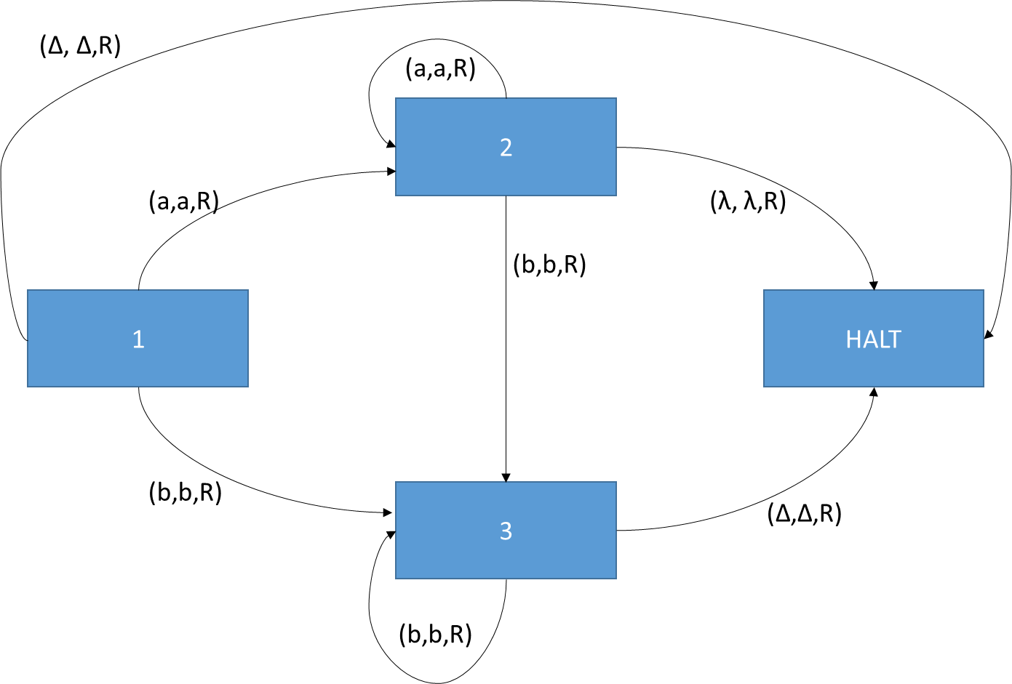
- Create a Turing machine that accepts strings for the language consisting of all words of even length (0 is even)
